The WebGoatv4 User & Install Guide

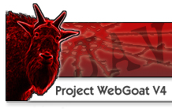
Copyright © 2003-2006 The OWASP Foundation.
This document is released under the GNU documentation license and is a Copyright of the OWASP Foundation. Please read and understand the license and copyright conditions. A copy of the license, and its terms, can be found at http://www.gnu.org/licenses/gpl.html.

A copy of this document in a transparent format as per the GNU Free Document License requirements is available from the OWASP web site. The original format of this work and this rendering of it are opaque under that license.

Trademarks
Java, Java Web Server, and JSP are registered trademarks of Sun Microsystems, Inc.
Microsoft Internet Explorer® is a registered trademark of Microsoft Corporation.
Firefox® is a registered applicable is a trademark of the Mozilla Foundation.
All other products and company names may be trademark of their respective owners. User of a term in this document should not be regarded as affecting the validity of any trademark or service mark.

Author Credits
Version 2: Anonymous Contributor
Initial Draft Version 4: Robert Sullivan (msp.sullivan@gmail.com)
Contributing Author:

Document History
- January 2004 Release v2
- March 2006 Release v4 initial draft

Contents
1. Introduction 1
Overview 1
2. Objectives 3
3. Tools required 4
Application Assessment Proxy 4
Application Spider 4
4. Using WebGoat 5
5. Installation 5
Installing Java and Tomcat 5
Installing to Windows 5
Installing to Linux 5
Installing to OS X (Tiger 10.4+) 5
Running 5
Building 6
6. Getting Started 7
7. Lesson Plans 9
8. Basic Operation 10
9. Proxy Utilization 13
10. Ready to Go! 14
11. How to write a new WebGoat lesson 15
Step 1: Set up the framework 15
Step 2: Implement createContent 15
Step 3: Implement the other methods 16
Step 4: Build and test <this must have changed in v4> 17
Step 5: Give back to the community 17

Figures
Figure 1: Sign In Page 7
Figure 2: Welcome Page 8
Figure 3: Show Lesson Plan 10
Figure 4: Show HTML 11
Figure 5: Show Params & Cookies 12
Figure 6: Show Java 12
Figure 7: LAN Settings 13
Figure 8: A WebScarab Session 14

1. Introduction

Overview
The WebGoatv4 application is designed to illustrate typical security flaws within web-applications. It is intended to teach a structured approach to testing for, and exploiting such vulnerabilities within the context of an Application Security Assessment.

A full Application Security Assessment testing methodology is being documented by http://www.owasp.org/testing/ and this will provide a superset of the issues demonstrated within the WebGoat. If may include a formal design and code review, for example. The WebGoat lessons aim to give practical training and examples relating ot the Implementation Review phase of the OWASP Web Application Security Testing Methodology.

The WebGoatv4 Application provides a testing platform for a typical application security assessment. The assessor is given the same information and rights as a typical customer or client of an on-line application.
- The application is web based
- The attack simulations are remote
All of the described techniques may be performed from any connected location.
- The testing is black-box
Source code is not supplied, but it can be viewed and downloaded.
- Credentials and operational information is provided

Of course, the teaching aspect of WebGoat means that certain information will be revealed that would not typically be available. This makes it possible to guide the tester through an assessment process.

The current lesson plans provided in WebGoatv4 include:

Http Basics
How to Exploit Thread Safety Problems
How to Discover Clues in the HTML
How to Exploit Hidden Fields
How to Exploit Unchecked Email
How to Bypass Client Side JavaScript Validation
Remote Admin Access
How to Bypass a Path Based Access Control Scheme
LAB: Role based Access Control
Using an Access Control Matrix
Forgot Password
How to Spoof an Authentication Cookie
How to Hijack a Session
Basic Authentication
LAB: Cross Site Scripting
How to Perform Stored Cross Site Scripting (XSS)
How to Perform Reflected Cross Site Scripting (XSS)
How to Perform Cross Site Trace Attacks (XSS)
Buffer Overflow (TBD)
How to Perform Command Injection
How to Perform Parameter Injection
How to Perform Blind SQL Injection
How to Perform Numeric SQL Injection
How to Perform String SQL Injection
LAB: SQL Injection
How to Bypass a Fail Open Authentication Scheme
Encoding Basics
Denial of Service from Multiple Logins
Forced Browsing
How to Create a Soap Request
WSDL Scanning
Web Service SQL Injection
The Challenge

Future releases of WebGoat will include more lessons and functionality. Should you have any suggestions for improvement or new lessons please contact bill@owasp.org with your ideas.

2. Objectives
Having followed the testing techniques within WebGoat, a tester should be able to:
- Understand the high-level interaction processes within a web-application
- Determine information within client visible data which data which could be useful in an attack
- Identify and understand data and user interactions which may expose the application to attack
- Perform tests against those interactions to expose flaws in their operation
- Execute attacks against the application to demonstrate and exploit vulnerabilities

3. Tools required
There are a number of tools to aid the wily application security assessor. By far the most relevant to this type of security assessment are local proxies and web/application spiders. To complete the full set of WebGoat lessons a web-proxy will be required.

Application Assessment Proxy
A normal web-proxy typically receives, processes and forwards HTTP and HTTPS traffic between the client and server. This is normally to provide a single point through which all web traffic passes – for example to monitor usage, improve performance through caching or apply security policies.

An application proxy tool is designed to intercept all HTTP and HTTPS communication between the local client browser and the server-side. It acts as a man-in-the-middle where all interaction may be monitored, reviewed and (importantly) modified.

Through such a tool, the assessor can determine exactly what data is passed between the Client and Server. Furthermore, they may analyze and modify the data in order to test the impact of the application.

It is essential for many of the lessons within WebGoat that an application assessment proxy, or software with equivalent functionality be used.

The following is recommended:
WebScarab: http://www.owasp.org/webscarab

Application Spider
Spidering or crawling a site should identify and follow all of the intended pages and links within a web site & application, and optionally store a local copy.

The results can then be analyzed to define a comprehensive list of target scripts, forms, pages and fields within the application for use in later testing.

Mirrored content can also be analyzed for relevant information far more quickly than through a manual or ‘on the wire’ analysis.

The following are recommended:
- HHTrack – www.httrack.com
- Form Scalpel – http://www.ugc-labs.co.uk/tools/formscalpel/
- WebScarab – www.owasp.org/webscarab

4. Using WebGoat
Having identified the objectives and required tools, we may now get started with the WebGoat lessons.

5. Installation
WebGoat is a platform independent environment.
It utilizes Apache Tomcat and the JAVA development environment.
Installers are provided for Microsoft Windows and UN*X environments, together with notes for installation on other platforms.

Installing Java and Tomcat
- <This section may not be needed, update for v4>

Installing to Windows
1. Unzip the Windows_WebGoat-x.x.zip to your working environment
2. To start Tomcat, browse to the WebGoat directory unzipped above and double click "webgoat.bat"
3. Start your browser and browse to:
http://localhost/WebGoat/attack
This link is case-sensitive. Make sure to use a large ‘W’ and ‘G’.

Installing to Linux
1. Download and install Java JDK 1.5 from Sun (http://java.sun.com)
2. Unzip the Unix_WebGoat-x.x.zip to your working directory
3. Edit the following line in webgoat.sh, set JAVA_HOME to your JDK1.5 path.
JAVA_HOME="SET ME TO YOUR JAVA 1.5 JDK PATH"
4. Since the latest version runs on a privileged port, you will need to start/stop WebGoat as root.
sudo sh webgoat.sh start
sudo sh webgoat.sh stop

Installing to OS X (Tiger 10.4+)
1. Unzip the Unix_WebGoat-x.x.zip to your working directory
2. Since the latest version runs on a privileged port, you will need to start/stop WebGoat as root.
sudo sh webgoat.sh start
sudo sh webgoat.sh stop

Running
1. Start your browser and browse to: http://localhost/WebGoat/attack
Notice the capital 'W' and 'G'
2. Login in as: user = guest, password = guest

Building
Skip these steps if you just want to run WebGoat
<this section is incomplete>
6. Getting Started
In order to start using WebGoat, Tomcat must be launched using the startup script/bat in the Tomcat bin directory.
For WebGoat to operate it must have permission to run as a server and allow some uncommon web behavior. When WebGoat is running it will make the host machine vulnerable to attack.

If the machine is connected to the internet it should be disconnected.

Running a personal firewall may prevent WebGoat from operating correctly. Disable any personal firewall while running WebGoat.

From a browser, the Tomcat server can be accessed on localhost port 80, e.g. http://127.0.0.1:8080

WebGoat resides in the WebGoat directory, and the lessons can be found at: http://127.0.0.1:8080/WebGoat/attack

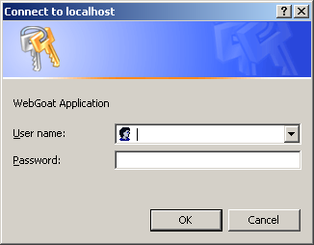
Figure 1: Sign In Page

WebGoat resides in the WebGoat directory, and the lessons can be found at: http://127.0.0.1/WebGoat/attack.

The WebGoat application enforces role based security. A login dialog requests credentials. Login as userid=guest, password=guest.

After a successful login the Tomcat server will show the WebGoat welcome page.
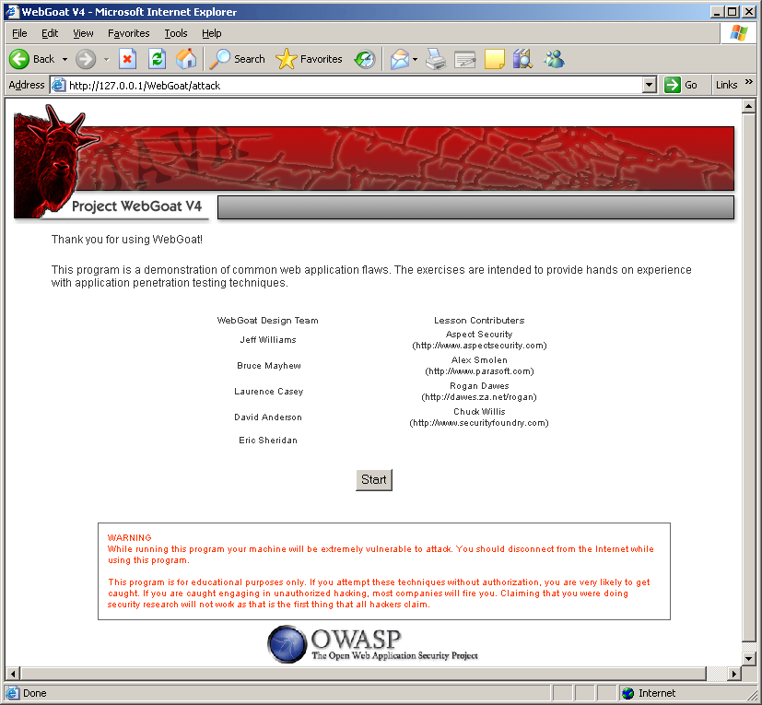
Figure 2: Welcome Page

7. Lesson Plans
The current lesson plans included in this release of WebGoatv4 include:
Http Basics
How to Exploit Thread Safety Problems
How to Discover Clues in the HTML
How to Exploit Hidden Fields
How to Exploit Unchecked Email
How to Bypass Client Side JavaScript Validation
How to Bypass a Role Based Access Control Scheme
How to Bypass a Path Based Access Control Scheme
How to Spoof an Authentication Cookie
Basic Authentication
How to Perform Cross Site Trace Attacks
How to Perform Command Injection
How to Perform Blind SQL Injection
How to Bypass a Fail Open Authentication Scheme
Web Service SQL Injection
The Challenge
For each lesson within WebGoat, an overview and objectives are provided. These are accessed through the Show Lesson Plan button.

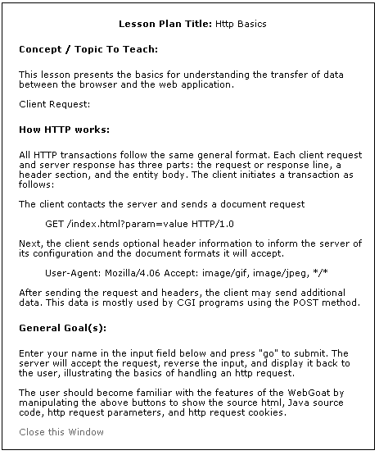
Figure 3: Show Lesson Plan

These lesson plans describe the operation of each aspect of the target application, the areas of interest relating to the security assessment and the type of attack that should be attempted.

8. Basic Operation
At each stage of an application security assessment, it is important to understand the operation of the target.

This typically involves:
- Examining client side content, such as HTML and script
- Analyzing communications between the client and server
- Reviewing cookies and other local data

The browser typically makes it simple to view HTML source. WebGoat expands on that with operations to Show Params, Show HTML, Show Cookies and Show Java.

Under normal circumstances the browser provides a feature to view HTML source. For Microsoft Internet Explorer this is “Source” under the View menu. For Firefox this is “Page Source” under the view menu. The Show HTML feature of WebGoat shows only the HTML that is relevant for the current lesson. This view does not include HTML for side and top bars.
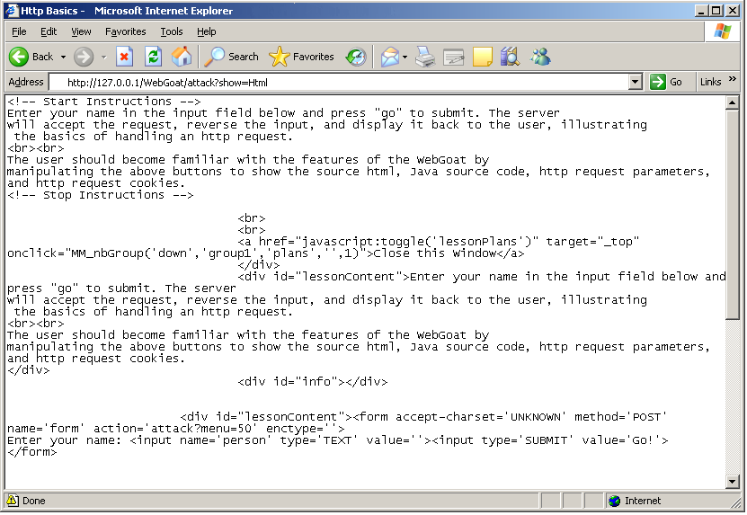
Figure 4: Show HTML

Parameters and cookies display in red. 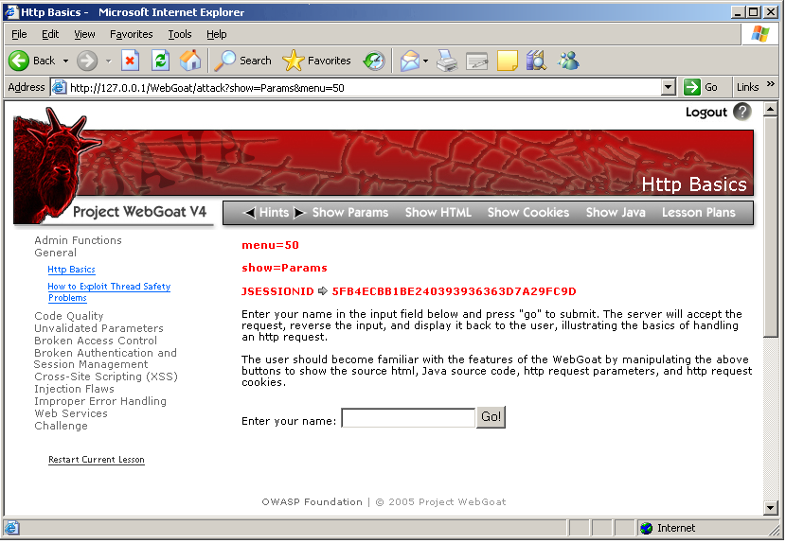
Figure 5: Show Params & Cookies

Show Java will open a new window containing source code.
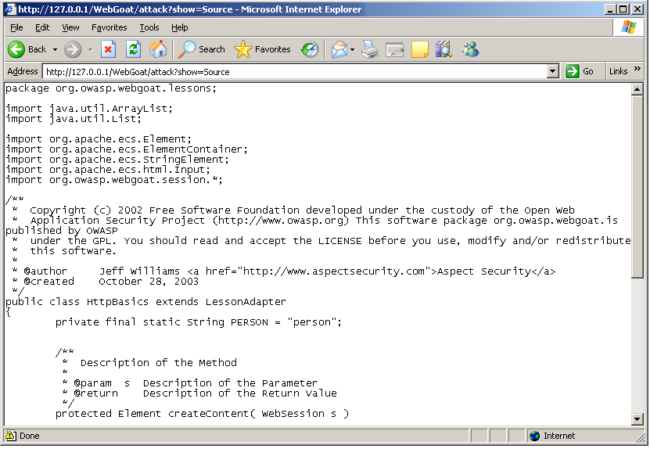

Figure 6: Show Java

9. Proxy Utilization
The features within WebGoat for revealing the workings of the application also need to be supplemented with the assessor’s application assessment proxy of choice.

This enables further analysis and modification of the client-server interaction, and data in transit.

Use and configuration will be unique to each tool, but the basic concepts are as follows:
- The application assessment proxy must sit between the client browser and the remote server.
- It should allow the display and modification of all HTTP data in transit.

Typically, the tool will either plug directly into the browser, or listen on another local port. When it plugs in directly, a special URL may need to be entered in the browser. When the tool listens on a port, the browser will probably need to be configured to use the proxy. In Microsoft Internet Explorer this can be done from the tool menu by choosing:
  - Choose the “Tools/Internet Options” menu item.
  - Choose the “Connections” tab
  - Hit the “LAN Settings…” button.
  - On the Local Area Network Settings dialog check the Proxy server checkbox.
  - Uncheck the “bypass proxy server” box
  - Enter the address and port where the proxy tool will be listening. The default listening port for WebScarab is <complete this>

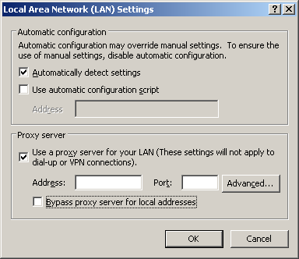
Figure 7: LAN Settings
Now, when receiving or sending data from the client browser it is possible to intercept, analyze and modify HTTP requests to test the application for security flaws in the target.
< a figure is needed here>
Figure 8: A WebScarab Session

- In using proxies of this kind, a number of capabilities become available to the assessor, including:
- All GET/POST parameters are available for modification, regardless of their hidden status
- Cookies, both persistent and non-persistent may be modified when entering or leaving the browser
- All client-side data validation can be bypassed, as the parameters can be modified immediately before being sent to the server
- Information regarding the caching of data (e.g. Pragma: no-cache) is exposed for analysis
- Server: and other headers are revealed, which may be useful for enumeration of the remote web-server and application-server technologies

10. Ready to Go!
All that remains is to start the WebGoat lessons.

One Last Point
If the problems or solutions do not reveal themselves to you, there are hints available to guide you through the lessons. Don’t be too eager, though – application testing is 10% technique and 90% lateral thinking. You will learn and remember much more if you struggle through the puzzles posed by the lessons. This will force you through a large number of failed attempts and finally a flash of insight that brings you to the solution. You can blame it on the Goat, but you can’t rely on him.

11. How to write a new WebGoat lesson
All you have to do is implement the abstract methods in LessonAdapter.

WebGoat uses the Element Construction Set from the Jakarta project. You should read up on the API for ECS at http://www.peerfear.org/alexandria/content/html/javadoc/ecs/HEAD/index.html.

WebGoat uses WTP. <add more details here>

Step 1: Set up the framework
Source for the class NewLesson.java

Step 2: Implement createContent
Creating the content for a lesson is fairly simple. There are two main parts:
- Handle the input from the user’s last request
- Generate the next screen for the user

This all happens within the createContent metnod. Remember that each lesson should be handled on a single page. Therefore it is important to design the lesson to work on one page.

Sample createContent Method
A good generic pattern for the createContent method is shown below:

// define a constant for the filed name
Private static final String INPUT = “input”;

Protected Element createContent(WebSession s)
{
ElementContainer ec = new ElementContainer();
try
{
// get some input from the user
// see ParameterParser for details
String userInput = s.getParser().getStringParameter(INPUT, “”);

// do something with the input
// -- SQL query?
// -- Runtime.exec?
// -- Some other dangerous thing

// generate some output – a string and an input field
ec.addElement(new StringElement(“Enter a string: “));
ec.addElement( new Input(Input.TEXT, INPUT, userinput));
}
catch (Exception e)
{
s.setMessage(“Error generating “ + this.getClass().getName());
e.printStackTrace();
}
return(ec);
}

ECS is quite powerful. See the Encoding lesson for an example of how to use it to create a table with rows and rows of output.

Step 3: Implement the other methods

The LessonAdapter class requires more methods to make a lesson fully functional. These methods allow the WebGoat user to navigate to the lesson and display lesson information. Each method is fairly simple and should only take a few minutes to implement.

Additional LessonAdapter Methods
 | Method | Description
1 | getHints | Return hints to the framework one at a time
2 | getCredits | Return credits to the framework for display
3 | getInstructions | This method will load the instructions HTML file from lesson_plans directory if you create one.
4 | getRanking | Sets the order of the lessons within a category. The lowest ranked lesson appears at the top.
5 | getTitle | The title is rendered as HTML

protected List getHints()
{
// Hints will be returned to the user in the order they
// appear below. The user must click on “next hint”
// before the hint will be didplayed.
List hints = new ArrayList();
hints.add( "There are no hints defined." );

return hints;
}

public Element getCredits()
{
return new StringElement("");
}

/**
* Gets the ranking attribute of the LessonAdapter object.
* The ranking denotes the order in which
* the menu item will appear in menu list for each category. The
* lowest number will appear as the first lesson.
*
* @return The ranking value
*/
public Integer getRanking()
{
return new Integer(10);
}

/**
* Fill in a descriptive title for this lesson.
* This will appear above the control area at the
* top of the page. This field will be rendered as html.
*
* @return The title value
*/
public String getTitle()
{
return "Untitled Lesson " + getScreenId();
}

Step 4: Build and test <this must have changed in v4>
After the new lesson is implemented ant can be used to build and deploy the new web application. First you want to remove the webgoat.war and the webgoat directory from the webapps directory. Next, cd to the webgoat directory and type:
- ant install
this will compile the new lesson and “install” the path into Tomcat. The lesson only needs to be installed once. If changes are made to the web application and another test is needed type:
- ant reload

Step 5: Give back to the community
If you have come up with a lesson that you think helps to teach people about web application security, please contribute it by sending it to the people who maintain the WebGoat application.

